Software Architecture Design

Overall Software Architecture Design

MRKun is a multi-tier web application employing the J2EE technology. The architectural design is applying MVC (Sun’s J2EE version) architectural design pattern, where presentation tier/client tier (JSP/HTML) acts as the View to capture and reflect the state of the data, web tier (Servlet) acts as the Controller to orchestrate the logical sequence/application behavior. Likewise, part of the business tier (Session EJB) also holds the responsibility for orchestrating the application behavior and plays a role in controller for handling respective Model (Entity EJB), whereas the other half of the business tier (Entity EJB), Value Object and data tier act as the Model in which they represent the state of the data.

MRKun MVC Design Concept

MRKun extends the concept of MVC architectural design pattern to a more extensible level. Following is the category and definition of different type of classes in MRKun MVC design:

View category:

Boundary class – This type of class is designed to be responsible for front-end user interaction including presenting and capturing user data. The implementation of boundary class will be JSP.

Controller category:

Boundary-controller class – This type of class is designed to be responsible for handling HTTP request and HTTP response. It orchestrates and defines the behavior of the boundary class. In addition to that, it encapsulates the knowledge of interfacing with respective entity-controller for fulfilling the request received from the front-end as well as passing along the entity class. The implementation of boundary-controller class will be Servlet.

Entity-controller class – This type of class is designed to be responsible for adding, deleting, updating and obtaining respective entity class as well as interfacing with the DAO Façade for data access operations. It orchestrates and defines the operations between boundary-controller class and the DAO Façade. The implementation of entity-controller class will be Session EJB.

Model category:

Entity class – This type of class is designed to be representing the state of the application. It is responsible for notifying the View of its changing state. In other words, it is the data-realization in the object level, a placeholder for the database data and often time its state is manipulated by boundary, boundary-controller and entity-controller class. The implementation of entity class will be Value Object.

Software Architecture Block Diagram

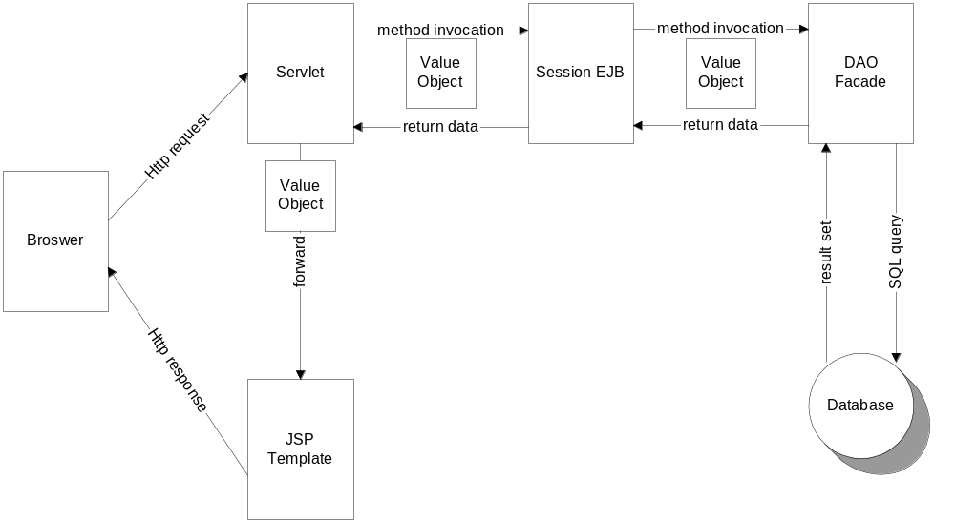

Software Architecture Walk Through

The software architecture is build around the MRKun MVC architectural design pattern. The JSP template represents the view and deals only with how the data is presented. There is no business logic in the JSP template, but only custom tags. The template usually generates HTML, but it could just as easily generate other types of output.
The model is the data, which in this case is represented by regular Value Objects. The value objects are returned as a result of the processing done by the business logic in Session EJBs. The JSP template reads the properties of the Value Objects to generate the output for the client.
The Servlet is the controller, which is basically a router of requests and response. The request is routed to the respective Session EJB for processing. The resulting data are then forwarded to the respective JSP template. The Weblogic application server will then compile the JSP template into Java class in which encapsulates all HTML strings for the web browser to display. The JSP template may vary depending on the returned data from the Session EJB. Example: If a login request succeeded the main page JSP template would be selected, but if the request failed, a “Login Error” page would be selected. Different JSP templates can also be selected based on client type, e.g. PC browser or I-mode phone.
Design Naming Convention

For facilitating a consistent design standard, MRKun employs a design naming convention and the definitions are as below:

Boundary class: All boundary classes are named in DR_XXXX/MR_XXXX where XXXX is the title for the respective page operation.

Boundary-controller class: All boundary-controller classes are named in XXXXCltr where XXXX is the title for the respective page operation.

Entity-controller class: All entity-controller classes are named in XXXXManager where XXXX is the title for the respective entity.

Entity class: All entity classes have their unique names.

